**COMMERCIAL SHELLFISHING SEASONS**

**Menemsha Pond**

**Commercial Bay Scallop Season Opens Tuesday November 1, 2011**

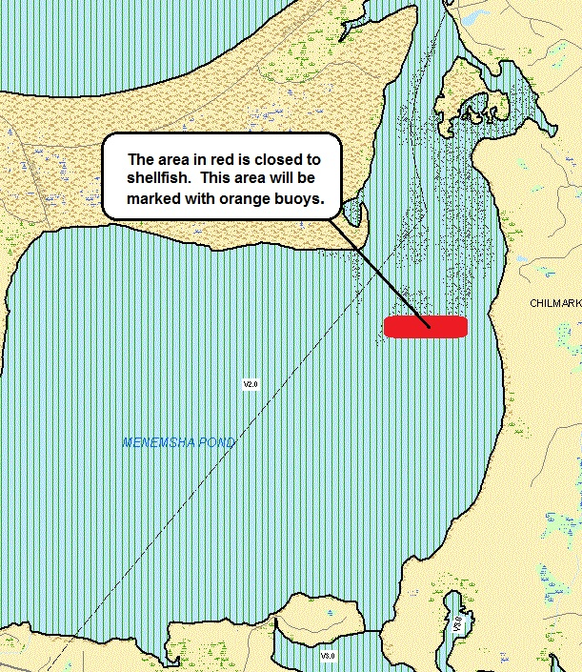

**Nashaquitsa Pond**

**Commercial Bay Scallop Season Opens Thursday December 1, 2011**

**Tisbury Great Pond**

**Recreational Oyster Season Opens Tuesday November 1, 2011**

**Commercial Oyster Season Opens Monday December 5, 2011**

***Mandatory shellfish meeting (December 1, 2011 at the Chilmark Town Hall) for all fishermen participating in the 2011 oyster season.***

***Please call the Chilmark Shellfish Department for any questions.***